**WORKSHEET 3**

**Student Name:** Vivek Kumar **UID:** 21BCS8129

**DOMAIN CAMP:** 16-01-2023 to 28-01-2023 **Section/Group:** DWWC-77

**Subject Name:** IT Skills (DSA)

# Question 1. CHEF AND LOCKOUT DRAWS

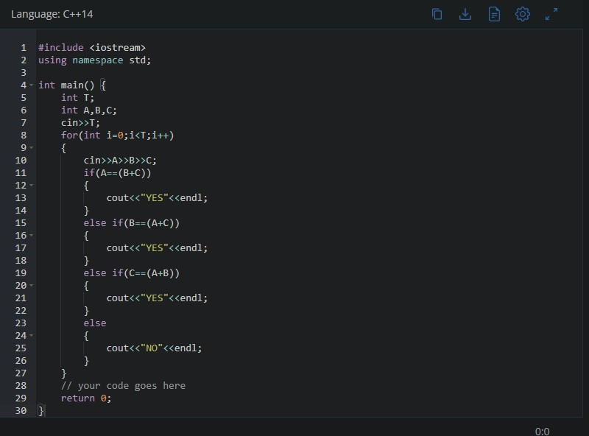

**SOLUTION:**

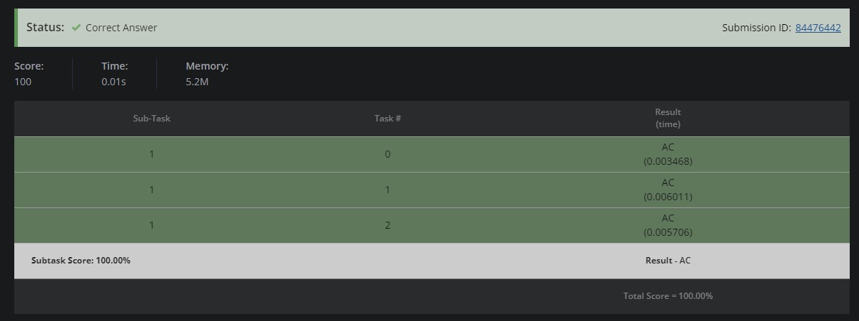

# CHEF AND PATIENTS

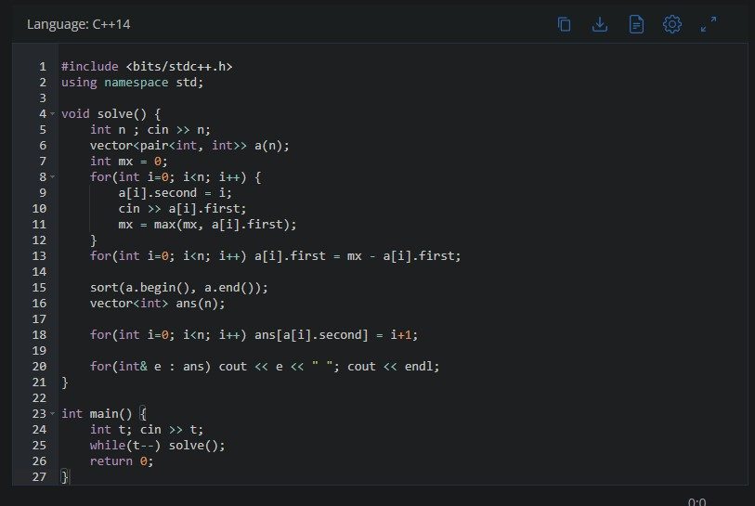

**SOLUTION:**

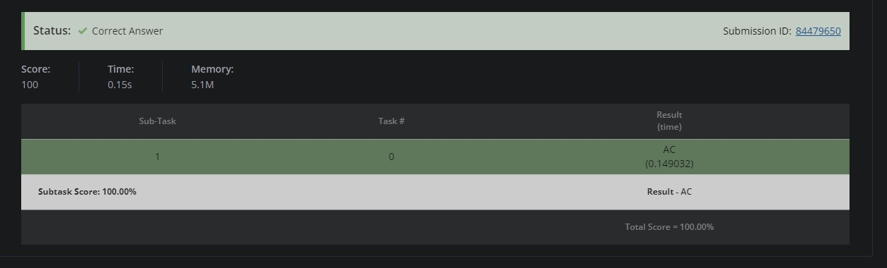

# CANDIES

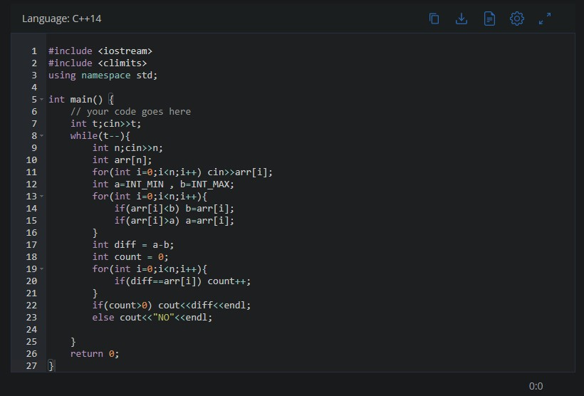

**SOLUTION:**

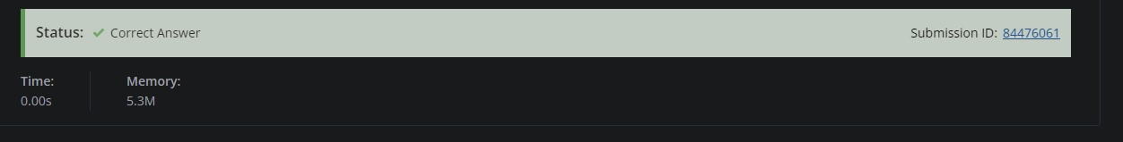

# CHEF AND PARTY

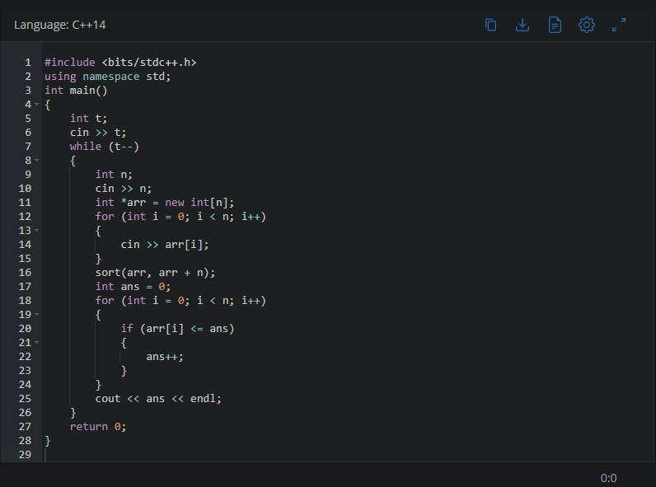

**SOLUTION:**

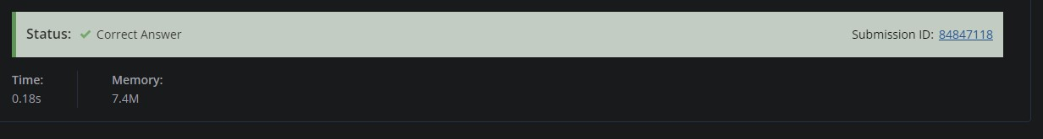

# INSERTION SORT LIST

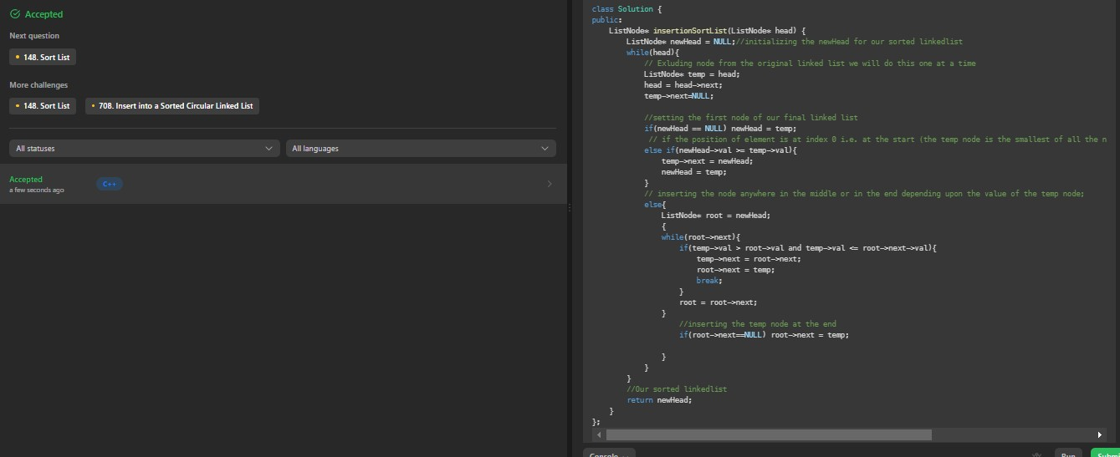

# Question 6. COLOR SORT

